Catalog

**Benicarta(4 variation)**

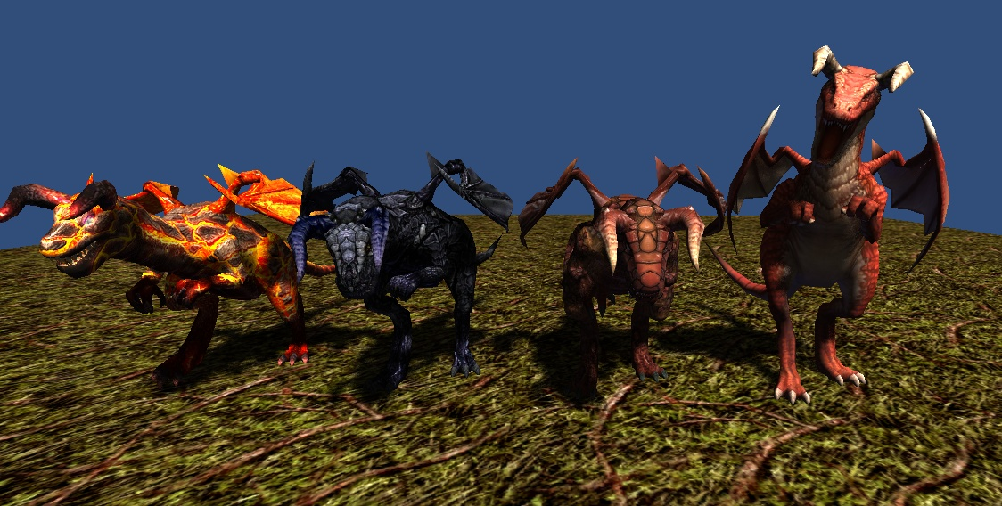

3186 polygons  
512x512x32bit 1 texture  
8 animations(idle, move, attack1, attack2, attack3, attack4, beaten, die)

**Giant Frog(4 variation)**

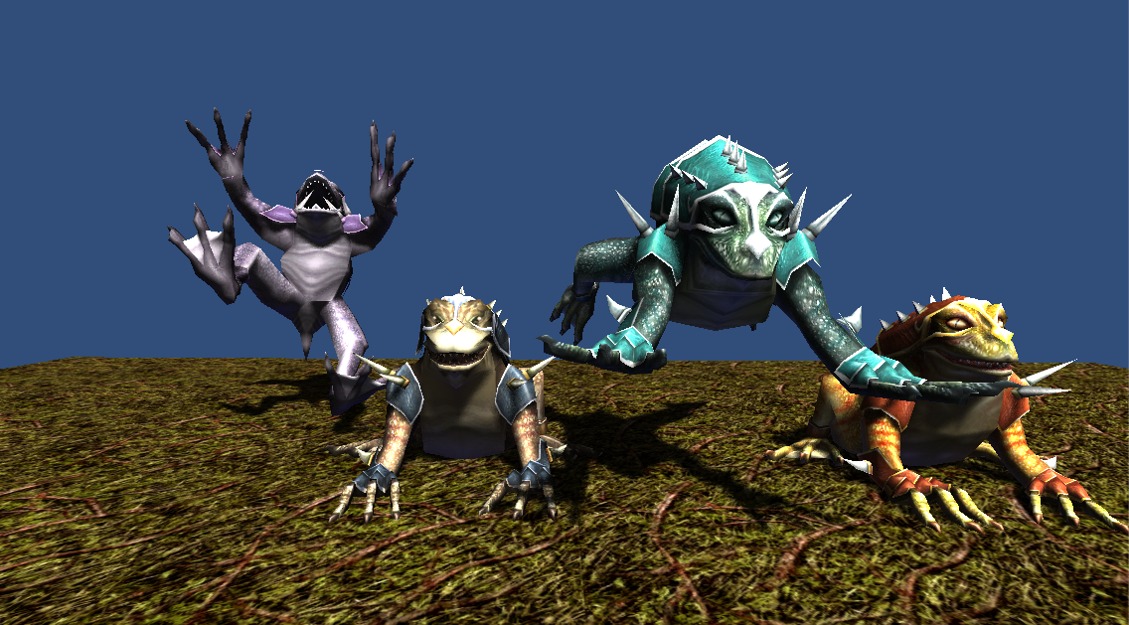

1774 polygons  
512x512x24bit 1 texture   
5 animations(idle, move, attack, beaten, die)

**Sarracenia(3 variation)**

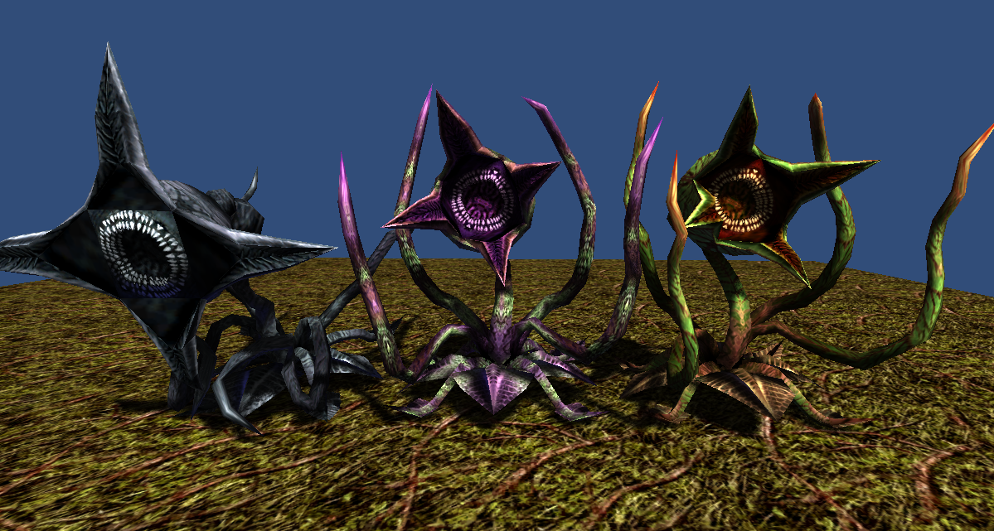

1488 polygons  
512x512x32bit 1 texture  
5 animations(idle, move, attack, beaten, die)

**Harpy(5 variation)**

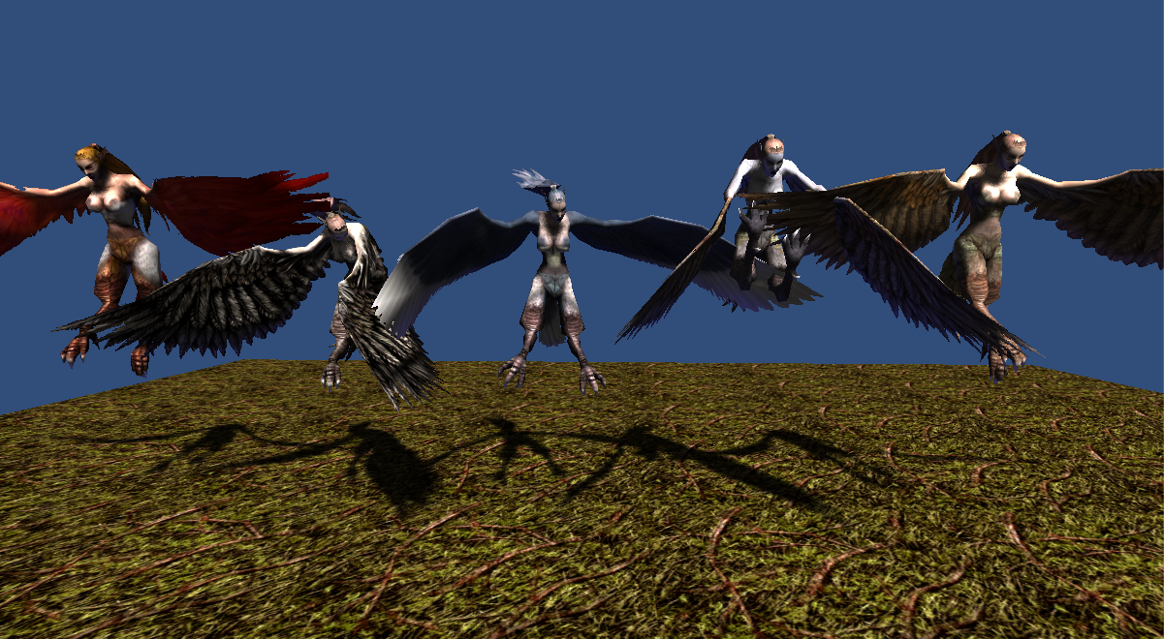

1406 polygons  
512x512x32bit 1 texture  
5 animations(idle, move, attack, beaten, die)

**Thank you for download.**

**Contact**

Homepage : http://www.studioez.net

E-Mail : admin@studioez.net